**PHP**

1. Create an account with Google Cloud Platform. This can be done by visiting [https://cloud.google.com](https://cloud.google.com/)

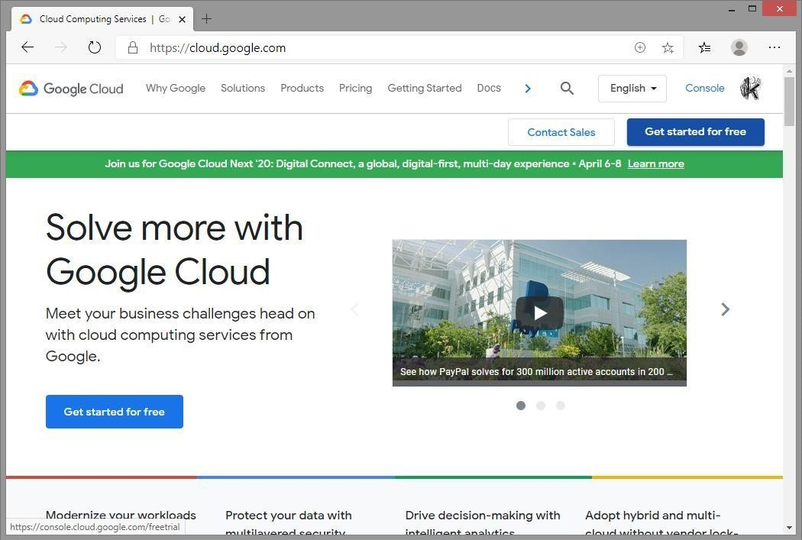

1. In Sign-up page step 1 of 2 choose country and agree to EULA.

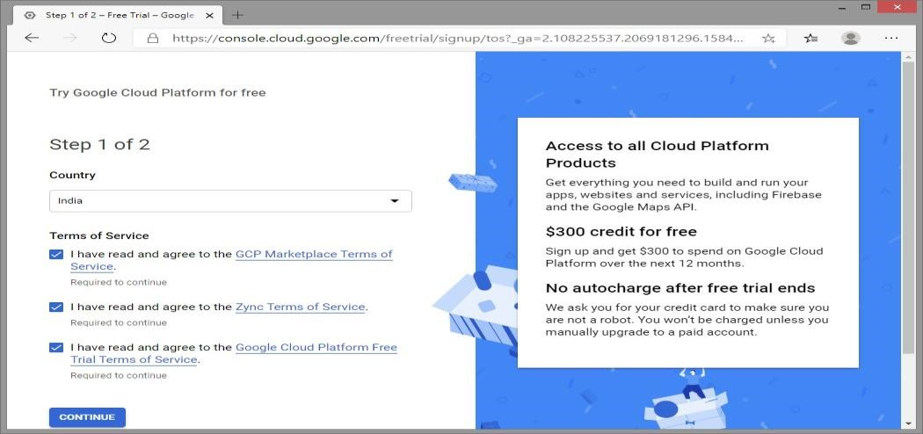

1. On the "Sign-up" page, step 2 of 2, we'll need to enter payment profile details. A charge of ₹1 will be applied to your card, which will then be refunded. You will receive a $300 credit, valid for one year, to use on Google Cloud services. After the first year, billing will not start automatically—charges will only apply with your consent.

4.

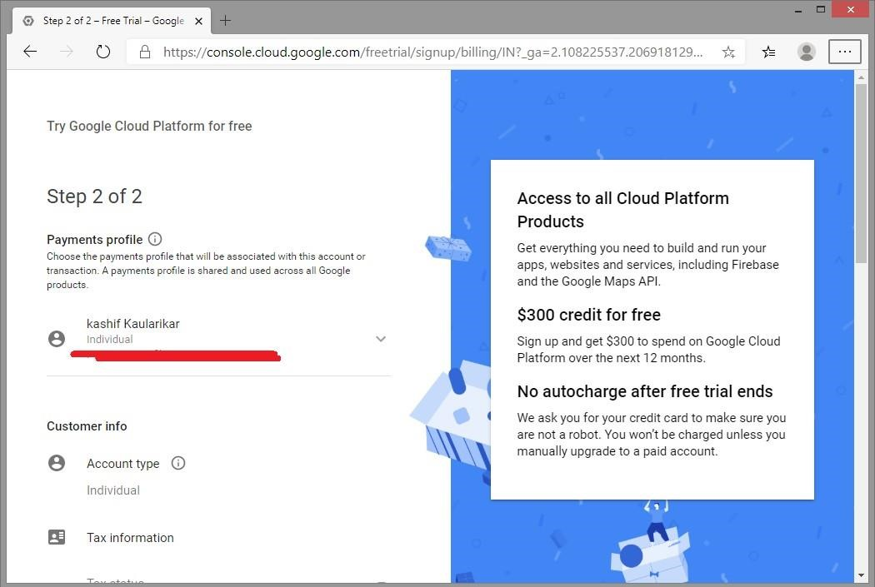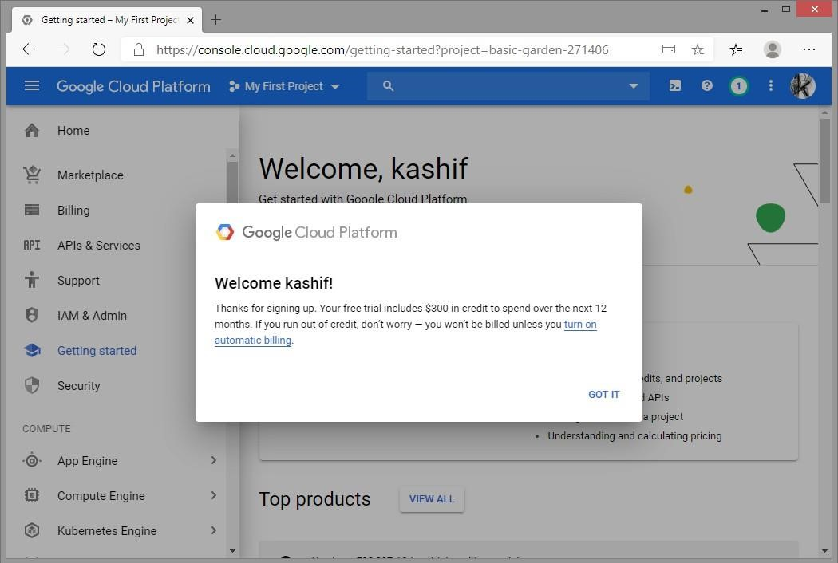

1. Click on *My First Project* and then *NEW PROJECT.*

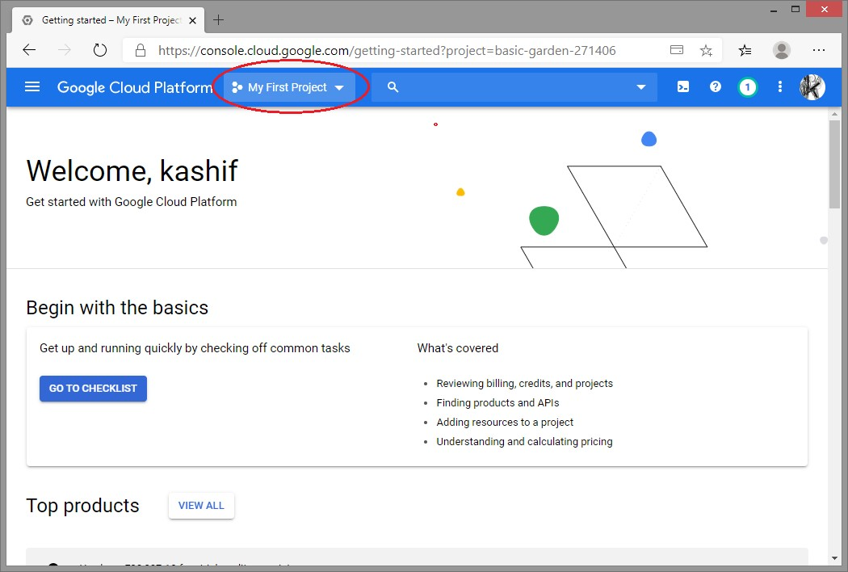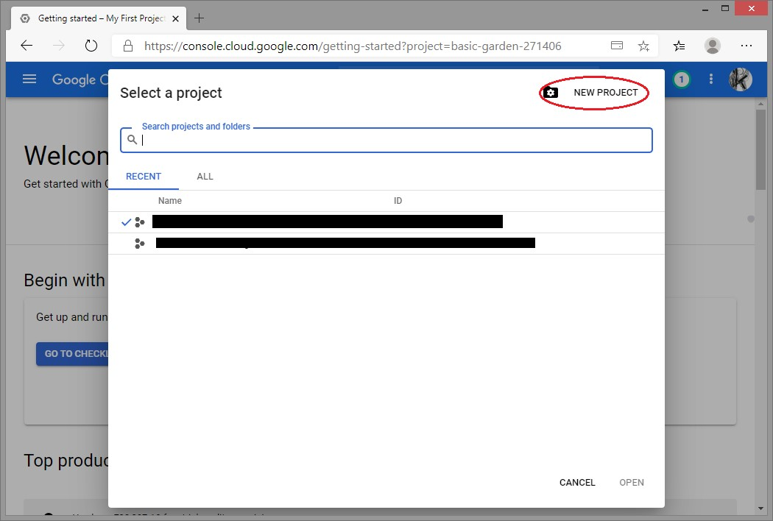

1. Provide Project name, this part will be unique. Location can be *No organization.*

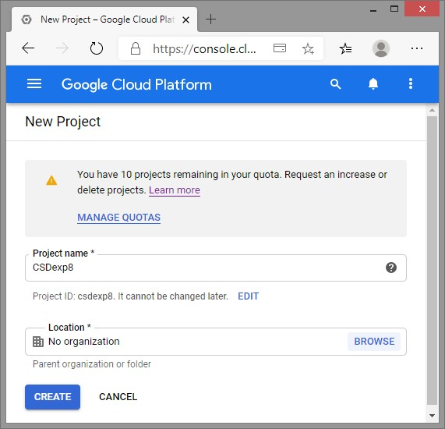

1. After Google cloud creates new project as per name specified in previous step, it opens up project home, showing dashboard. Highlighted part will be unique.

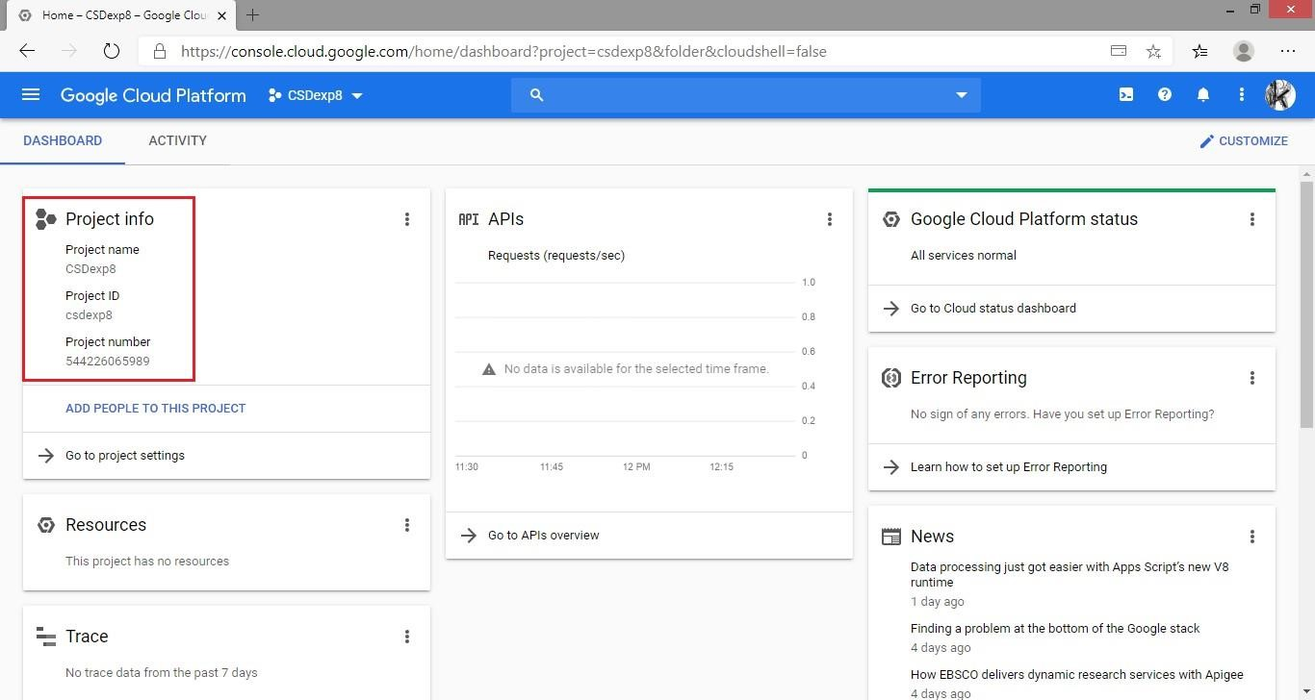

1. Create a new configuration file *app.yaml.* yaml file contains information about your app's code, such as the runtime and the latest version identifier. Each service in your app has its own app. yaml file, which acts as a descriptor for its deployment*.*

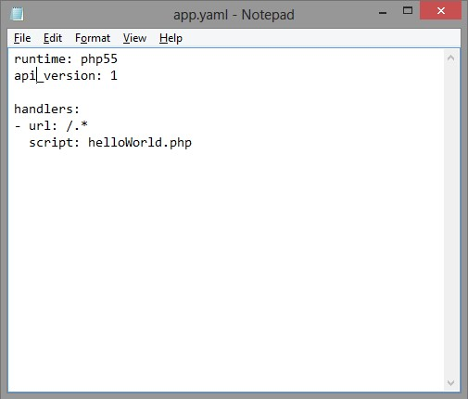

1. Create a PHP code to upload and run.

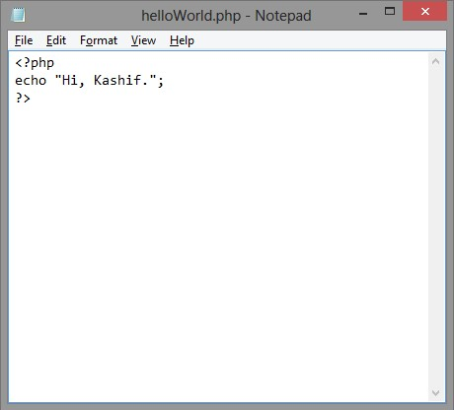

1. In order to deploy and run the PHP code on Google cloud platform, we have to visit <https://cloud.google.com/sdk/docs>to download latest *Google Cloud SDK* and to know how to install it.

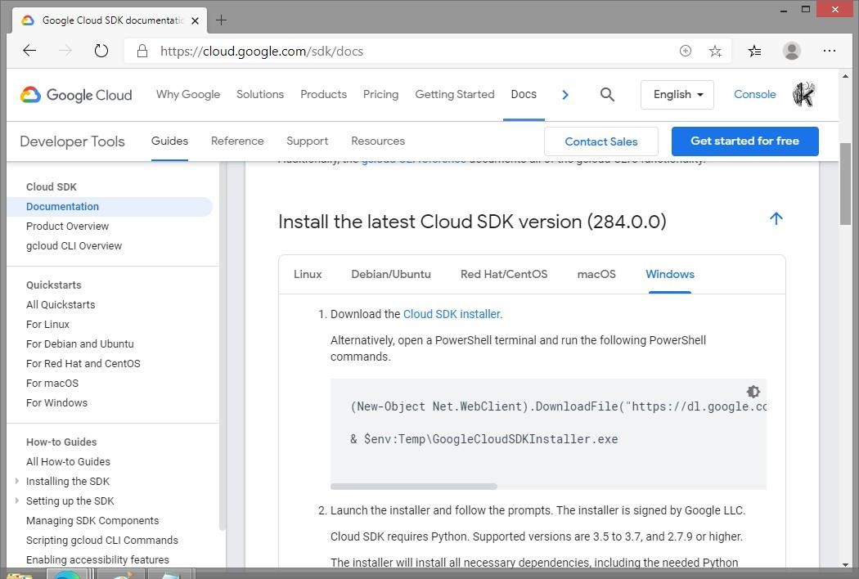

1. This SDK will also require PHP installed on machine, hence download latest PHP from <https://www.python.org/downloads/>and install same.

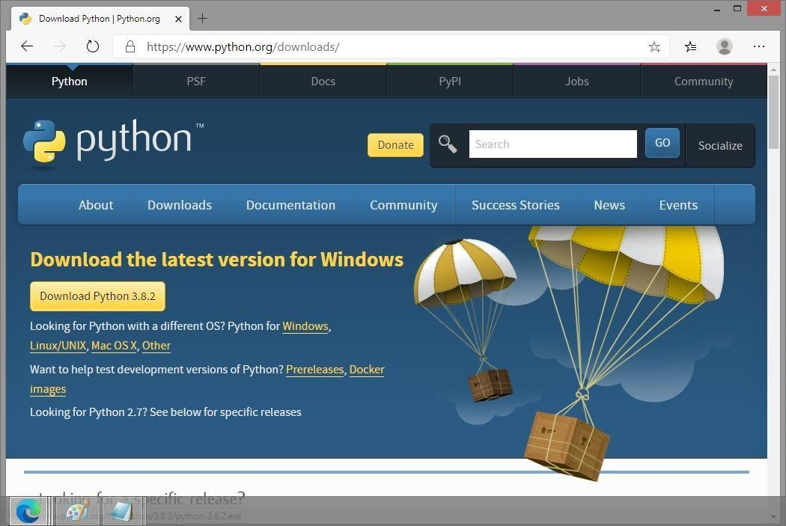

1. After installation of PHP, open Google cloud SDK installer. It will take some time to download and install *SDK from Google Server*. At end of installation check *Start Google Cloud SDK Shell* and *Run ‘gcloud init’ to configure the Cloud SDK*.

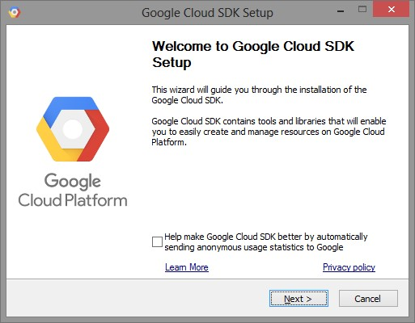

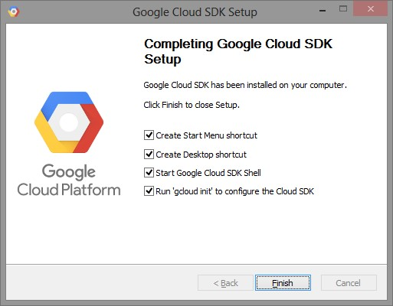

1. Previous step will open up command prompt with *gcloud init* command running automatically. It will ask you to login using Google account on which you have joined Google Cloud Platform. After successful login web browser page of *cloud.google.com* will show *You are now authenticated with Google Cloud SDK.*

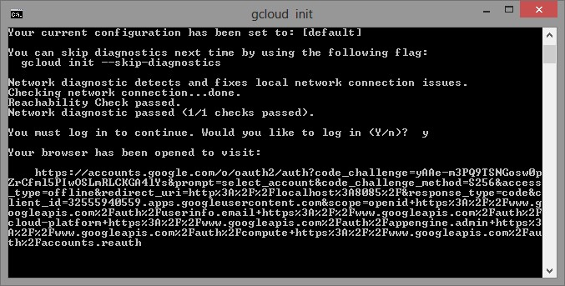

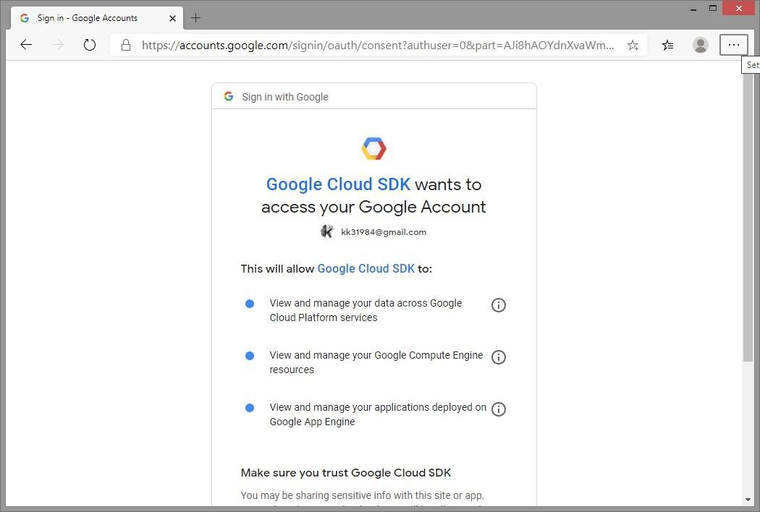

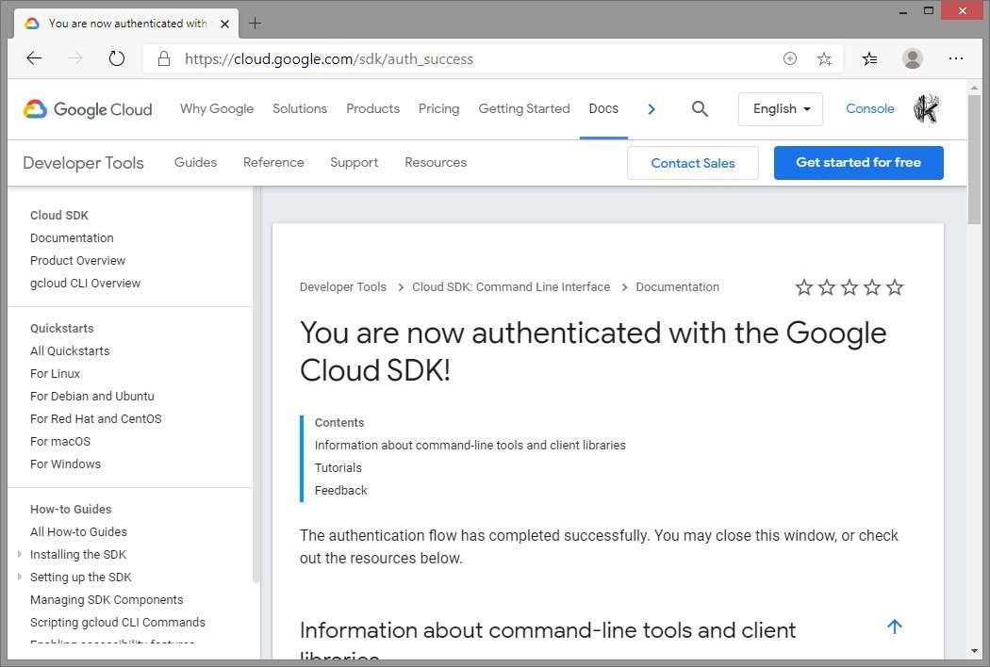

1. In command prompt, running in background will ask you to select project you want to deploy and run. Enter appropriate number and hit *enter*.

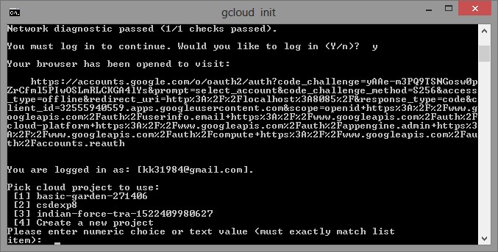

1. Change directory to folder where PHP and YAML file is residing.

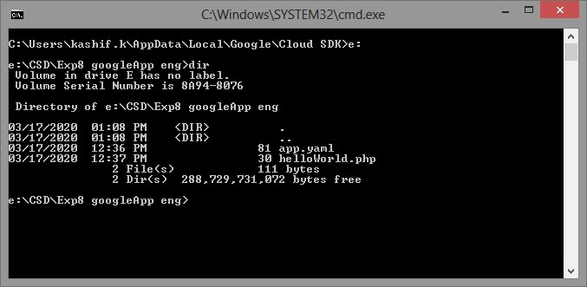

1. Type *gcloud app deploy* and select region of Google Data Center where you want to deploy your app, press *5* and press *Enter* for *asia-south1, i.e. Mumbai*. Press *Y* to continue with deployment. Result will show URL to launch your GoogleApp. Alternatively you can type *gcloud app browse* to open your App in browser. Further you can make change in PHP code, or add more PHP code and repeat step 15.

